**Sprint 1 Plan**

Product Name: Toss Time

Team Name: Sinked Inc.

Completion Date: Oct. 19th, 2021

**Goal**:

For this sprint, we aim to establish the basis for our project by investigating the many technologies available to aid us. We’ll begin by implementing a map using Google API, and if time permits, we may be able to place markers at locations on the map.

**Task Listing**

“As a dye player, I want an app that shows nearby dye games on a map, so I can play more.”

Task 1: Set up XCode for all team members ( 2 hours )

Task 2: Do plenty of research into Google API & Databases ( 4 hours )

Task 3: Implement a map that can be viewed on a mobile device (iOS). ( 6 hours )

Task 4: App can center around some location / marker on the map. ( 2 hours )

Task 5: Be able to post a marker on the map. ( 4 hours )

> Involves databases - could carry over into Sprint 2

Total time for user story: ( 18 hours )

**Team Roles & Initial Task Assignments**

Cole Hennig - Product Owner - Tasks 1,2

Kenny Blum - Scrum Master - Tasks 1,2

Anton Kozintsev - Team Member - Tasks 1,2

Ryan Ahrari - Team Member - Tasks 3,4

Steve Beurard - Team Member - Tasks 3,4

**Sprint 1 Initial Burn-Up Chart**

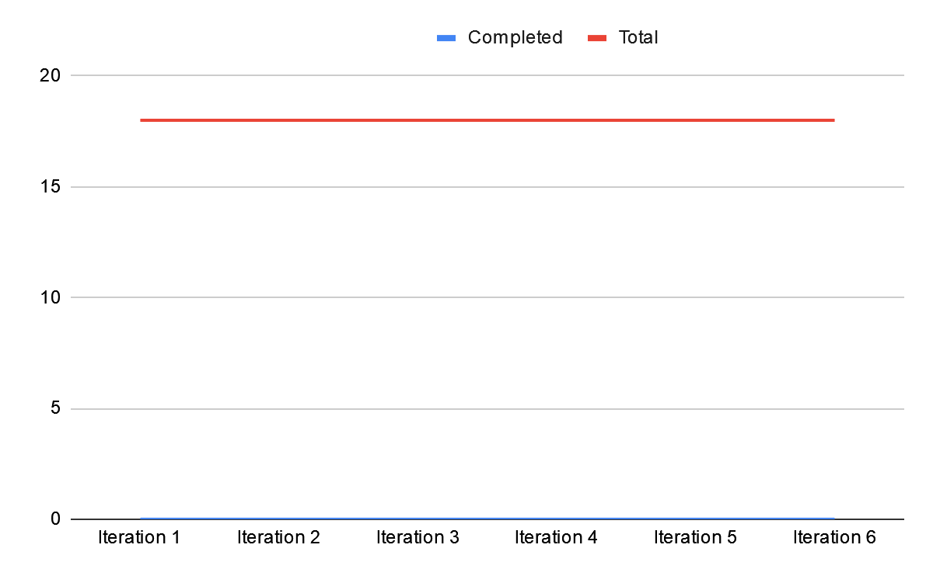

**Initial Scrum Board**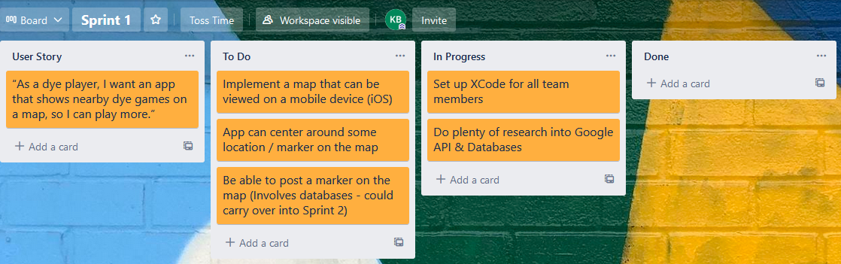

**Scrum Times**: Monday / Wednesday / Friday @ 2:30PM